**LOGIN PAGE**

PASSWORD:

USERNAME:

**REGISTRY MODULE**

Here is where members are registerd and also managed from.

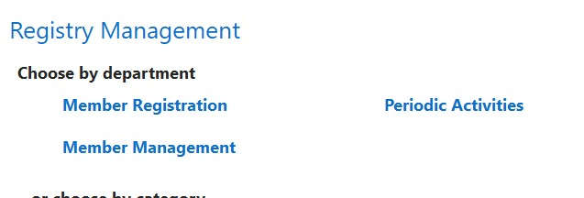

**MILK MANAGEMENT MODULE**

**MILKCOLLECTION**

MILK REPORTS

Milk Payout

Milk collection

**MILK COLLECTION**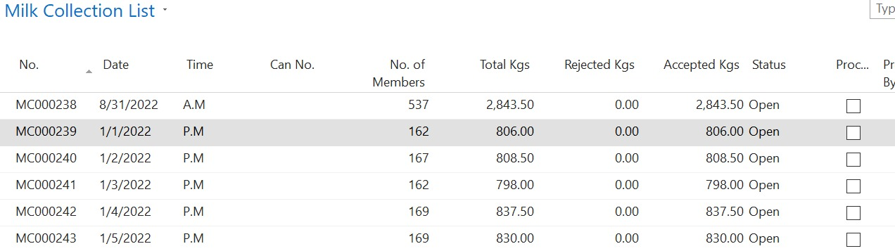

**REPORTS**

MILK COLLECTION BY ROUTE REPORT

MILK COLLECTION REPORT

**MILK COLLECTION REPORT**

